A

**Major Project Report**

On

**Face Recognition Attendance System**

Submitted in partial fulfillment of the requirements of the degree of

**BACHELOR OF TECHNOLOGY**



**Submitted by :-**

**ABHISHEK PANCHOLI (18ETCCS002)**

DEPARTMENT OF COMPUTER SCIENCE AND ENGINEERING

TECHNO INDIA NJR INSTITUTE OF TECHNOLOGY, UDAIPUR

RAJASTHAN TECHNICAL UNIVERSITY

**May 2022**



**CERTIFICATE**

This is to certify that this project report “**Face Recognition Attendance System**” is the work of “ **Abhishek Pancholi (18ETCCS002)** ” who has carried out the project work under my supervision. I approve this project for submission of the Bachelor of Technology in the **Department of Computer Science and Engineering, Techno India NJR Institute of Technology**, affiliated to Rajasthan Technical University, Kota.

**Mr. Aaditya Maheshwari**

Project Incharge

Computer Science

**ABSTRACT**

1. **Purpose**
   1. **Introduction**

**Face Recognition** is a biometric method of identifying an individual by comparing live capture or digital image data with the stored record for that person.

* 1. **Scope**

Provides an automated attendance system that is practical, reliable and eliminates disturbance and time loss of traditional attendance systems.

Present a system that can accurately evaluate student's performance depending on their recorded attendance rate.

* 1. **Document Overview**

**Face Recognition Attendance System** is marking of attendance based on this technology.

In simple words, The system works on face recognition where each student in the class is photographed and their details are stored in a server. The system will recognize the faces and verify the presence or absence of each student.

**ACKNOWLEDGEMENT**

It gives me immense pleasure to express my deepest sense of gratitude and sincere thanks to my highly respected and esteemed guide **Mr. Aaditya Maheshwari (Assistant Professor, Project In charge), TINJRIT** for their valuable guidance, encouragement and help for completing this work. Their useful suggestions for this whole work and cooperative behavior are sincerely acknowledged.

I would like to express my sincere thanks to the **Head of Department, Dept. of CSE TINJRIT** for giving me this opportunity to undertake this project.

I also wish to express my indebtedness to my parents as well as my family member whose blessings and support always helped me to face the challenges ahead.

At the end I would like to express my sincere thanks to all my friends and others who helped me directly or indirectly during this project work.

Place : Udaipur

Name : Abhishek Pancholi

**TABLE OF CONTENT :-**

**Certificate**……………………………………………………...**2**

**Abstract**………………………………………………………...**3**

**Acknowledgement**……………………………………………..**4 Table Of Content**………………………………………………**5**

**Methodology**…………………………………………………...**7**

* Waterfall Model……………………………………………..**7**
* Requirement…………………………………………………**7**
* Design……………………………………………………….**8**
* Implementation……………………………………………...**8**
* Verification…………………………………………………..**8**
* Maintenance…………………………………………………**9**

**Tools And Technology**………………………………………..**10**

* + Tools………………………………………………………..**10**
  + Library Used………………………………………………..**11**

**Significance Of Project**……………………………………....**13**

**System Requirements to Run this Project**………………....**14**

* Versions…………………………………………………….**14**
* Supported Operating System………………………………**14**
* Processor…………………………………………………...**14**
* Ram and HDD/SSD………………………………………..**15**
* Graphic Unit………………………………………………..**15**

**System Context Diagram**…………………………………….**16**

**Data Flow Diagram**…………………………………………..**17**

**System Architecture**………………………………………….**18**

* Training phase……………………………………………...**18**
* Testing Phase………………………………………………**19**
* Registration Phase………………………………………….**20**

**DataBase Dictionary**…………………………………………**21**

**Testing**………………………………………………………...**22**

* Testing Methodology………………………………………**22**

**Scope**…………………………………………………………..**23**

**Modification and Improvement**……………………………..**24**

**Learning and Experience**………………………………………...**25**

**Bibliography**………………………………………………….**26**

**Methodology :-**

1. **Waterfall Model** is a sequential approach, where each fundamental activity of a process is represented as a separate phase, arranged in linear order. It is also referred to as a linear-sequential life cycle model. It is very simple to understand and use. In a waterfall model, each phase must be completed before the next phase can begin and there is no overlapping in the phases.
2. In the waterfall model, you must plan and schedule all of the activities before starting working on them (plan - driven process).

* **Requirement :-**

Requirements are very well documented, clear and fixed. Product definition is stable. Technology is understood and is not dynamic. There are no ambiguous requirements. All possible requirements of the system to be developed are captured in this phase and documented in a requirement specification document.

* + Requirement Documents.
  + Prepare Use Cases.
* **Design :-**

The requirement specifications from the first phase are studied in this phase and the system design is prepared. This system design helps in specifying hardware and system requirements and helps in defining the overall system architecture.

* + Software Architecture.
  + Map the Stakeholders.
* **Implementation :-**

With inputs from the system design, the system is first developed in small programs called units, which are integrated in the next phase. Each unit is developed and tested for its functionality, which is referred to as Unit Testing.

* + Construct the Software.
  + Data Storage & retrieval.
* **Verification :-**

All the units developed in the implementation phase are integrated into a system after testing of each unit. Post integration the entire system is tested for any faults and failures.

* + Install.
  + Test and Debug.
* **Maintenance :-**

Once the functional and non-functional testing is done; the product is deployed in the customer environment or released into the market.

There are some issues which come up in the client environment. To fix those issues, patches are released. Also to enhance the product some better versions are released. Maintenance is done to deliver these changes in the customer environment.

* + Check Error.
  + Optimize Capabilities.

1. All these phases are cascaded to each other in which progress is seen as flowing steadily downwards (like a waterfall) through the phases. The next phase is started only after the defined set of goals are achieved for the previous phase and it is signed off, so the name "Waterfall Model". In this model, phases do not overlap.

**Tools And Technology Used :-**

* **Tools :-**
  + Pycharm.

PyCharm is a dedicated Python Integrated Development Environment (IDE) providing a wide range of essential tools for Python developers, tightly integrated to create a convenient environment for productive Python, web, and data science development.

* + Visual Studio Code.

Visual Studio Code is a streamlined code editor with support for development operations like debugging, task running, and version control. It aims to provide just the tools a developer needs for a quick code-build-debug cycle and leaves more complex workflows to fuller featured IDEs, such as Visual Studio IDE.

* + Python Interpreter.

The Python interpreter is a virtual machine, meaning that it is software that emulates a physical computer. This particular virtual machine is a stack machine: it manipulates several stacks to perform its operations (as contrasted with a register machine, which writes to and reads from particular memory locations).

* **Library used :-**

Python Libraries are a set of useful functions that eliminate the need for writing codes from scratch. There are over 137,000 python libraries present today. Python libraries play a vital role in developing machine learning, data science, data visualization, image and data manipulation applications, and more.

* + Python 3.8
  + Open cv

OpenCV (Open Source Computer Vision Library) is an open source computer vision and machine learning software library. OpenCV was built to provide a common infrastructure for computer vision applications and to accelerate the use of machine perception in the commercial products.

* + Dlib

It's a landmark's facial detector with pre-trained models, the dlib is used to estimate the location of 68 coordinates (x, y) that map the facial points on a person's face.

* + Cmake

CMake is an open-source, cross-platform tool that uses compiler and platform independent configuration files to generate native build tool files specific to your compiler and platform. The CMake Tools extension integrates Visual Studio Code and CMake to make it easy to configure, build, and debug your C++ project.

* + Numpy

NumPy is a Python library used for working with arrays. It also has functions for working in the domain of linear algebra, fourier transform, and matrices. NumPy was created in 2005 by Travis Oliphant. It is an open source project and you can use it freely.

* + Face-Recognition

Recognize and manipulate faces from Python or from the command line with. the world's simplest face recognition library. Built using dlib's state-of-the-art face recognition. built with deep learning.

* + Os

The OS module in Python provides functions for creating and removing a directory (folder), fetching its contents, changing and identifying the current directory, etc. You first need to import the os module to interact with the underlying operating system.

* + Datetime

In Python, date and time are not a data type of their own, but a module named datetime can be imported to work with the date as well as time. Python Datetime module comes built into Python, so there is no need to install it externally. Python Datetime module supplies classes to work with date and time.

Significance of Project :-

* Reduction in use of pen and paper
* More trusted environment and no proxy,
* A small contribution of ours in saving trees,
* Everything is monitored digitally
* Time will be reduced and easy conduction of tests, assignments as notes facilities.
* Parents themselves can check the student performance.

**System Requirements**

**to Run this Project :-**

* **Versions :-**
  + Pycharm 2022.1
  + Visual Studio Code 2019
  + Python 3.8
  + Cmake 3.22.4
  + Dlib 19.24.0
  + Face Recognition 1.3.0
  + Numpy 1.18.4
  + OpenCv Python 4.2.0.34
  + DateTime 4.4

* **Supported Operating Systems :-**

* + Windows 7 and above
  + High Sierra or Above
* **Processor :-**
  + Intel Core i3 -8th Gen or Above.
  + Apple M1.
  + AMD Ryzen 3250U or Above.
* **RAM and HDD :-**
  + 6 GigaByte or Above.
  + 50 GigaByte or Above. (HDD)
  + 50 GigaByte or Above. (SSD)
* **Graphic Unit :-** 
  + Intel 5500 UHD or Above.
  + AMD Ryzen 3200G or Above.

# **System Context Diagram :-**

A system context diagram (SCD) in [engineering](https://en.wikipedia.org/wiki/Engineering) is a [diagram](https://en.wikipedia.org/wiki/Diagram) that defines the boundary between the [system](https://en.wikipedia.org/wiki/System), or part of a system, and its environment, showing the entities that interact with it. This diagram is a high level view of a [system](https://en.wikipedia.org/wiki/System). It is similar to a [block diagram](https://en.wikipedia.org/wiki/Block_diagram).

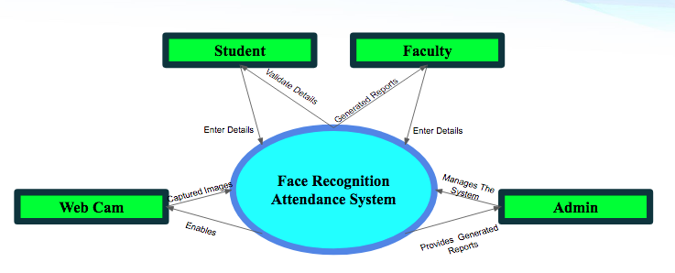

**Data Flow Diagram :-**

A data-flow diagram is a way of representing a flow of data through a process or a system (usually an information system). The DFD also provides information about the outputs and inputs of each entity and the process itself. A data-flow diagram has no control flow — there are no decision rules and no loops.

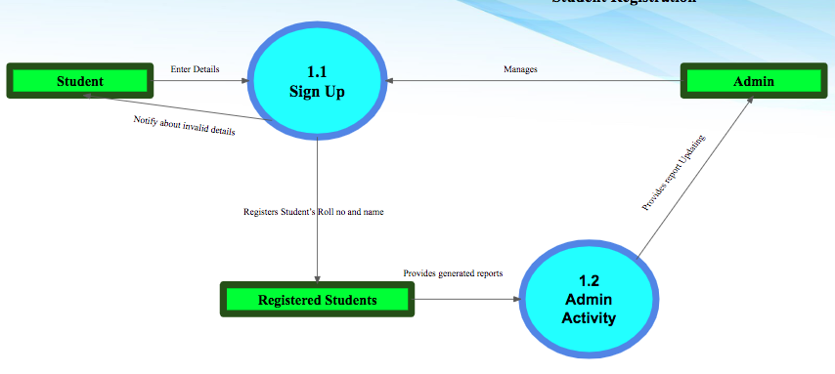

**System Architecture :-**

A system architecture is the conceptual model that defines the structure, behavior, and more views of a system. An architecture description is a formal description and representation of a system, organized in a way that supports reasoning about the structures and behaviors of the system.

* **Training Phase :- Registration**

A phase where you are basically training the algorithms to create the right output. In the learning phase you are having the input parameters. Basically the configuration of the model and you have the input data. What you're doing is you are training the algorithm.

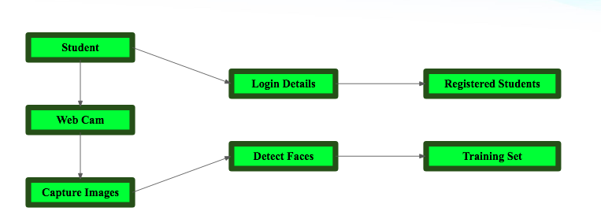

* **Testing Phase :- Attendance**

The testing phase allows you to find out how well your Model is Accurate in the task.

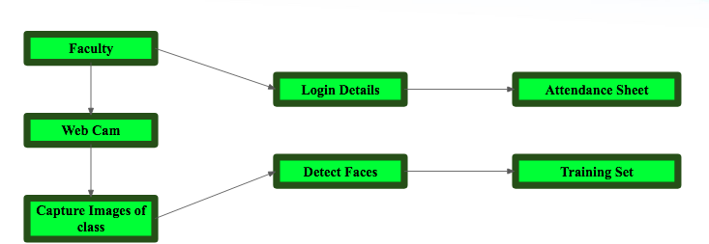

* **Registration Phase :-**

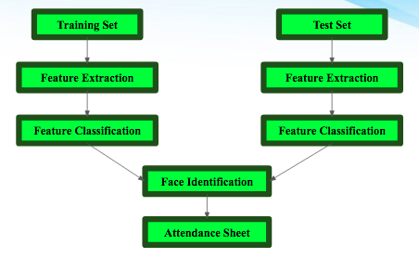

**Database Dictionary :-**

A data dictionary contains metadata i.e data about the database. The data dictionary is very important as it contains information such as what is in the database, who is allowed to access it, where is the database physically stored etc. The users of the database normally don't interact with the data dictionary, it is only handled by the database administrators.

| **Field Name** | **Data Type** | **Length** | **Constraint** | **Description** |
| --- | --- | --- | --- | --- |
| **Roll_no** | int | 3 | Primary Key | Student Roll no |
| **Name** | Varchar | 20 | Not null | Name of Student |
| **Date** | Date | 10 | Not Null | Date of Attendance |
| **Time** | Time | 10 | Not Null | Time of Attendance |
| **Attendance** | Varchar | 7 | Present or Absent | Attendance of Student |
| **Image** | .png | 100 | Size must be of 11kb | Image of Student |

**TESTING :-**

* **Testing Methodology :-**
  + Companies rely on software more than ever to provide and manage information with strategic and operational importance and to provide key decision support. Rising customer expectations for fault-free, requirements-exact software have increased awareness of the importance of software testing as a critical activity.
  + We begin the testing process by developing a comprehensive plan to test the general functionality and special features on a variety of platform combinations. Strict quality control procedures are used. The process verifies that the application meets the requirements specified in the system requirements document and is bug free. At the end of each testing day, we prepare a summary of completed and failed tests. Applications are not allowed to launch until all identified problems are fixed. A report is prepared at the end of testing to show exactly what was tested and to list the final outcomes.
  + Our software testing methodology is applied in three distinct phases: Unit testing, System testing, and Acceptance testing.
    - Unit Testing
    - System Testing
    - Program Testing
    - String Testing
    - System Testing
    - User Acceptance Testing

**Scope :-**

Project scope is the part of project planning that involves determining and documenting a list of specific project goals, deliverables, tasks, costs and deadlines. The documentation of a project's scope is called a scope statement or terms of reference.

* Provides an automated attendance system that is practical, reliable and eliminates disturbance and time loss of traditional attendance systems.
* Present a system that can accurately evaluate student's performance depending on their recorded attendance rate.

**Modification and Improvement :-**

* Time consumed in accessing the records of the students can be reduced.
* Easy To Use GUI can be created.
* Automatically manage attendance of students.
* Students can get informed by email or mobile notification automatically.
* List of less attendance students can be made on a single click.
* More time taken in registration of students.
* Send weekly/monthly attendance to students automatically.

**Learning and Experience :-**

* From scratch to working software, carrying out real-world software projects in our academic studies helps us to understand what we have to face in industry.
* It was a wonderful experience working on **Face Recognition Attendance System** with enthusiastic and like-minded people wherein I explored a part of Artificial Intelligence, i.e. image processing, which relates to our system from capturing images, detecting faces, storing them in a database, extracting facial features, recognizing them and generating attendance through different algorithms, books, websites and with the guidance of our guide.
* I have learned most of the industrial strategies used for completion of project by keeping accounts of time, quality, and budget.
* This project was a door to a Stairs of Success towards the bright Software Engineering career.

**Bibliography:-**

I’am using various type of books and websites from which we get the Knowledge about Python and Data Science which are following: -

* <https://www.python.org>
* <https://code.visualstudio.com>
* [https://www.google.com](https://www.google.com/)
* [https://www.w3schools.com](https://www.w3schools.com/)
* <https://www.tutorialspoint.com/index.htm>
* <https://www.wikipedia.org>
* <https://www.coursera.org/in>
* <https://www.udemy.com>
* <https://www.youtube.com>
* <https://stackoverflow.com>
* <https://www.quora.com>